**Null and Undefined:**

Let x; //**undefined**

Console.log(x);

Console.log(typeof x);

Let x= 9; //number when value is not given at declaration then at that time the value is undefined.

Let x = null;

Let y;

Console.log(x==y); //true but strict equality console.log(x===y) //false

Undefined and Null contain two different data type; undefined is a data type itself and null is primitive.

Explicitly defining the x value as undefined.

Let x= undefined;

Console.log(x);

**Function scope VS Block Scope:**

ES5 has function scope & that is because of **hositing**

**ES6 doesn’t have hoisting. If you declare variable with “var” keyword then hoisting will be there.**

**Console.log(x);**

**Var x= 9;**

**The output of the above code will be “Undefined”.**

**It should show error but it is showing undefined because when we use var keyord inside the javascript engine it happens like this.**

**Var x;**

**Console.log(x);**

**X=9; // all the var declaration will be brought at top place and value assigned remains at same place.**

**“Hoisting means bringing the declaration on the top”**

**Block scope introduce from ES6 and we use let keyword;**

**What is Automatic semicolon inserition (ASI)?**

**When we forget the semicolon then the automatic semicolon is inserted.**

**Function test(){**

**Return**

**{**

**a:5**

**}**

**}**

**Const obj = test();**

**Console.log(obj);**

**Why this is returning as undefined? => because internally what is happening is JS is putting semicolon(;) after the return statement and ending the return statement abruptly so its returning that. To fix this just do like this:**

**Return{**

**a:5**

**}**

**Difference between Rest and Spread Operator?**

**From ES6 onwards there are (…) used in many places. Sometimes they are called REST operator while sometime it’s called spread operator why?**

**Function sum(…nums){**

**Console.log(nums);**

**}**

**Sum(4,5);**

**Sum(5,6,7,8);**

**Output will be in an array [4,5] /[5,6,7,8]**

**This is called REST operator and there is no restriction while calling. First we’re calling with 2 value and then we’re calling with three value.**

**With REST parameter we’ll be creating the array.**

**The REST parameter should always be the last one.**

**Function(…a,b) = This will not work but function(a,…b)=this will work.**

**ES5 = argument object=> an array like object. Its not an array(key value pair)**

**Function sum(){**

**Console.log(arguments);**

**}**

**Sum(4,5);**

**Sum(5,6,7,8);**

**Output: {‘0’:4,’1’:5} for sum(4,5)**

**When we try to use this with arrow function then this will not work at all.**

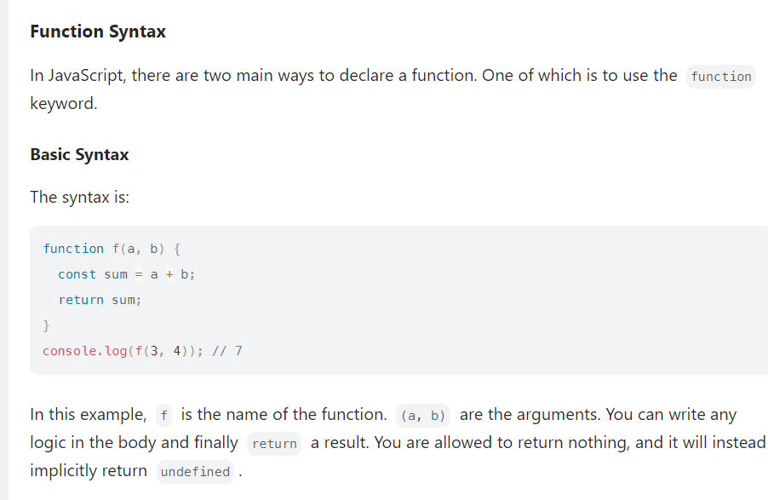

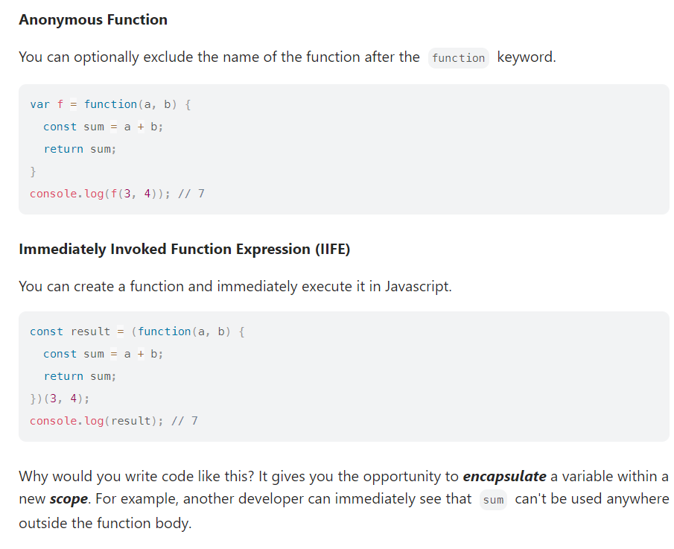

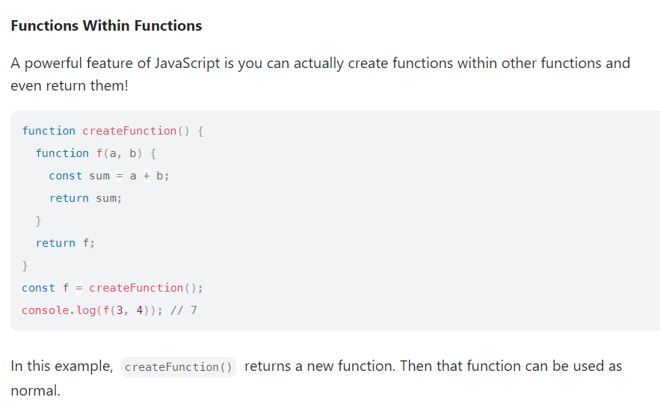

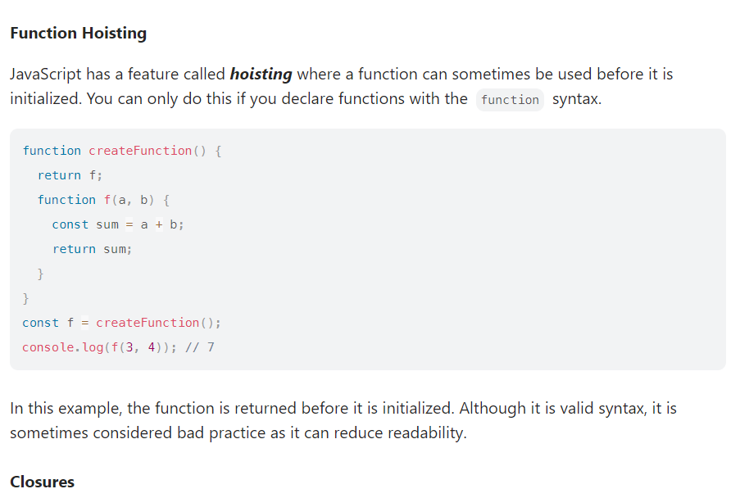

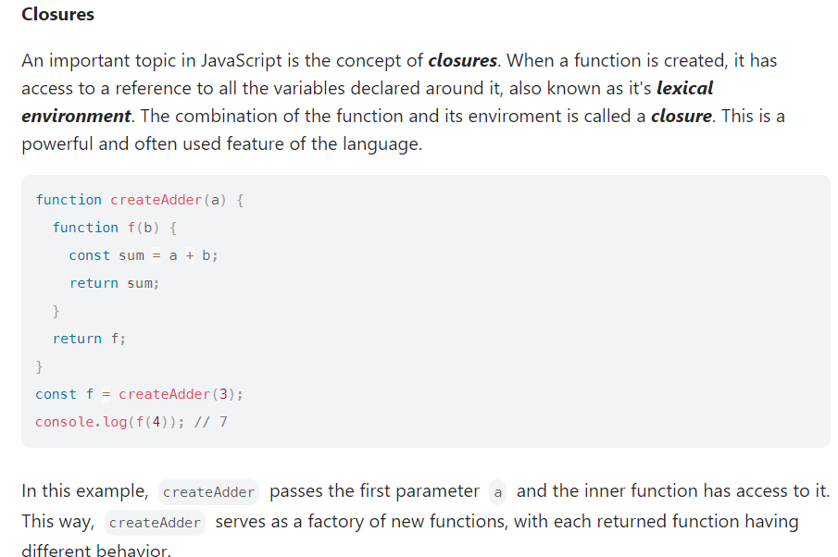

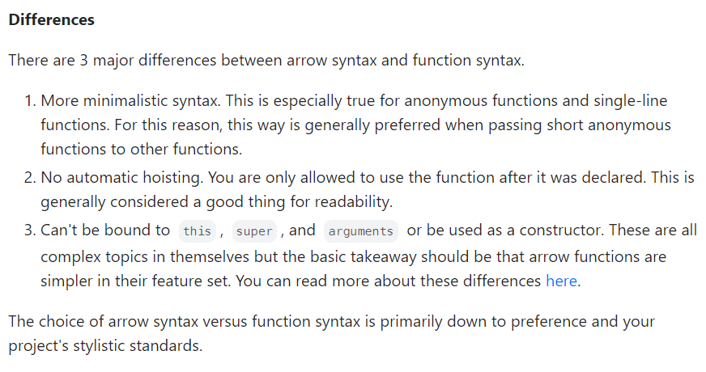

**As the Rest operator puts the separate data values in one array, the spread does exactly the opposite.**

**Sum(5,6,7) = [5,6,7]**

**[5,6,7] = 5,6,7**

**For example:**

**Let arr1 = [1,2,3,4,5];**

**Let arr2 = […arr1,6,7,8];**

**Output([1,2,3,4,5,6,7])**

**Let arr1 = [4,47,90,2];**

**Console.log(Math.max(arr1)) => output : undefined because we’ll have to pass the element of the array individually.**

**Here we are passing everything at once. So to fix this use Spread feature.**

**Console.log(Math.max(…arr1));**

**When you get Infinity or –Infinity as output?**

Console.log(Number.MAX_VALUE)

Console.log(-Number.MAX_VALUE)

If(num===Number.NEGATIVE_INFINITY){

Return “Negative inifintie value”;

}else{

Return num;

}

**To check finite or infinite value there is also isFinite() method in Javascript.**

**How will you go put a validation for positive or negative Infinity?**

**If(num===Number.NEGATIVE_INFINITY){**

**Return “Negative infinite value”;**

**}else{**

**Return num;**

**}**

**If(num===Number.POSITIVE_INFINITY){**

**Return “Positive infinite value”;**

**}else{**

**Return num;**

**}**

**When do you get NaN as Output?**

Let a = 5;

Let b = “value”;

Console.log(a*b); =? NAN why because number and string can’t be multiply.

Let a = 5;

Let b=”value”;

If(!(isNaN(a*b))

Console.log(“Valid”);

Else

Console.log(“invalid”);

**isFinite() method is used to check for NaN as well as infinity.**

**Output of NaN==NaN or NaN===NaN both of these gives us false.**

**Arrow Functions:**

Three functional behavior which you must discuss is:

1. “this” object doesn’t work with arrow function
2. “arguments” object doesn’t work with arrow function.
3. You cannot use “new” to call arrow function.

Traditional way:

Function test() {

}

Test()

Function expression :

Const test = function (){

}

Test();

Arrow function is the function expression only:

Syntax:

Const test = ()=>{

}

Test();

The inside of this object in arrow and traditional way:

In old tradition way:

Const obj = {

test(){

Console.log(this);

}

}

Obj.test(); = > this will give us output of test object why because it is referring to the test object while calling. But when we try to do same thing using the arrow function.

Const obj = {

Test: ()=>{

Console.log(this);

}

}

Obj.test(); => this will give us the WINDOW obj instead of test object why is this happening?

Earlier function used to act as class also. Now in ES6 function doesn’t need to act as a class.

Why this doesn’t work with arrow function?

We already have a class keyword to deal with the classes, so we don’t need the function to act as a class.

Can you write IFFE with arrow function?

(()=>{

Console.log(“IFFEE”);

})();

**How does a closure work in Javascript?**

When a function comes under another function a closure is created.

Closure pattern remembers outer variable & also helps to access outer scope members.

Function outer(){

Function inner(){

Console.log(“Inner called…”);

}

Inner();

}

Outer();

Function outer(){

Function inner(){

Console.log(“Inner called…”);

}

Return inner;

}

Const cl = outer();

Cl();

Const addCounter = ()=>{

Let counter = 0;

Return ()=>{

Counter++;

Return counter;

}

}

Const cl = addCounter();

Cl();

Cl();

Cl();

Output is : 1,2,3

**How can you access private variable or a function outside the scope?**

We can do that using closure.

**How can sum(5)(6) return 11?**

We can achieve this by using a concept called currying.

It’s a unique way to call inner functions where you can pass arguments partially or pass multiple arguments in a function but 1 argument at a time.

Const sum = function(a){

Return function(b){

Return a+b;

}

}

**Const cl= sum(5);**

**Const ans = cl(6);**

**Console.log(ans);**

**Simplyfing the above code:**

**Const sum = a=>b=>a+b;**

**Const ans = sum(5)(6);**

**Console.log(ans)**

**Currying = calling the function partially.**

**Const pricecalc = (price)=>{**

**Return (dPer)=>{**

**Return price*dPer;**

**}**

**}**

**Const discountAmount = pricecalc(300);**

**Console.log(discountAmount(.5));**

**Console.log(discountAmount(.3));**

**Questions:**

**What is currying?**

**Importance of currying : Currying is an incredibly useful technique of functional programming which solves various purposes like passing partial parameters or avoiding unwanted repetitions like we tired with product price where price was passed only once.**

**Iterables and Interators:**

**Iterator concept new in ES6:**

Let arr = [4,5,6,7];

For(let i of arr){

Console.log(i);

}

Let arr = [4,5,6,7];

Let itr = arr[Symbol.iterator]();

Console.log(itr);

Console.log(itr.next());

**Making an object iterable:**

**To make an object literal iterable it should have method having key value as Symbol.iterator**

Let obj = {

Start:10,

End:15

}

Obj[Symbol.iterator] = function(){

Const itr = {

Next(){

If(obj.start<=obj.end){

Return{value:obj.start++, done:false}

}else{

Return{done:true}

}

}

}

Return itr;

}

For(let i of obj){

Console.log(i);

}

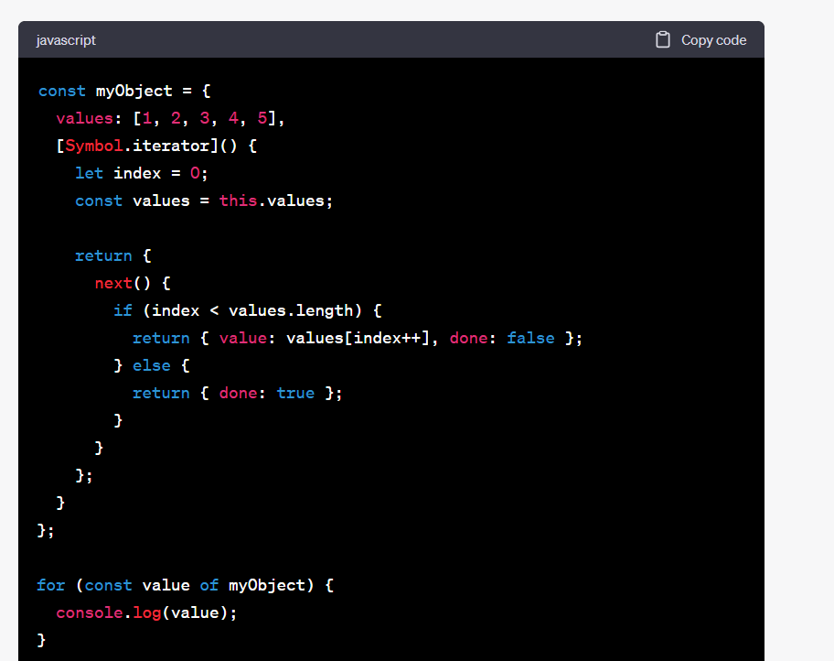

**Memory management and Garbage Collection:**

Obj

Variable =🡺 location / memory is released when program ends

Function

In short clearing these free locations is the process of collecting the garbage or garbage collection or GC.

**Mark and Sweep Algorithm: The algorithm starts from the root object and checks for the references linked. In case if this algorithm finds unreachable locations, then those are the locations to be removed.**

**Summary:**

Memory allocation is done automatically. As long a refrences exist, there will not be any cleaning or garbage collecting.

**When we have a circular refrence then at that time there will be memory leak.**

**Let teacher = new Teacher();**

**Let student = new Student();**

**Teacher.student = student;**

**Student = null;**

**Student.teacher = teacher;**

**How do you handle error?**

Try{

}catch(err){

Err.name, err.message, err.stack

}

**Throw** keyword to throw your own custom error.

Let a=8;

Let ageErr = new Error(“Invalid age”);

Try{

If(a<18){

Throw ageErr;

}else{

}

}catch(err){

Console.log(err.message);

}

Try{

//statements

}catch(err){

//statements

}finally{

//statements

}

Try{

}finally(err){

//statements

}

Array:

Let arr = [4,7,9];

let arr = [10,”rab”,true];

**Array of an object literal:**

let arr = [

{pCode:1,pName:’Apple’},

{pCode:2,pName:’orange’}

];

**Traversal:**

Old way:

For(let i=0;i<arr.lenght;i++){

Console.log(arr[i]);

}

**From ES6 we have for…in & for..of for looping:**

Let arr = [“Es5,”ES6”,”ES7”];

For(let elm in arr){

Console.log(elem);

}

Output:0,1,2,3

**Whenever we use the “FOR..IN” it will always give us the index instead of the value.**

**If you want the value then you use : “FOR…OF”**

**For(let elm of arr)**

**Console.log(elm)**

**Output:ES5,ES6,ES7**

**FOR EACH:**

Let arr = [“ES5”,”ES6”,”ES7”,”ES8”];

Arr.forEach((elem,index)=>{

Console.log(elem,index);

});

**IMP: you cannot break the forEach loop:**

**Add, Remove, Insert, Replace elements in the array:**

**Add/Remove:**

**-**push() -pop()

-shift() -unshift()

arrName.push(ele1,[ele2,…eleN])

push() method adds1 or more element at the end of an array and it returns the new length i.e count of the elements after adding elements.

Unshift() method add 1 or more element at the beginning of an array & it returns the new length i.e count of elements after adding the element.

Pop() and shift are remove the element. Pop from the last whereas the shift() from the beginning.

Splice() changes the original array:

It can be use to do all the operation like add(), remove()

Add element at the beginning of the array:

Arr.splice(0,0,”New”);

Splice() method is used to remove a specific element.

Arr.splice(2,1);

Splice() method returns deleted items, if there is nothing to delete then it will return an empty array.

**Searching elements in an Array:**

**IndexOf()**

**lastIndexOf()**

**includes()**

**arrName.indexOf(searchElement,[startIndex]);**

**lastIndexof is same as indexOf but it will give the index of the last element found.**

**Arr.includes(searchElement, [startIndex])**

**Includes() method returns Boolean values i.e true or false.**

**For EG:**

**Salaries = [4000,2500,5500];**

**You want to retrieve the salary which is more than 3000**

**You can use find(), findIndex() or filter()**

**Let arr = [2300, 4500, 5600, 7800, 1200];**

**Const rVal = arr.find((element)=>{**

**Return element>3000;**

**})**

**Console.log(rVal);**

**Output: 4500**

**Find() will only search for the first element and returns it when it founds that.**

**If you want to find all the element in an array which are greater than the 3000 then you have use FILTER:**

**Filter returns a new array.**

**Map() Method:**

Map() method returns new array and it doesn’t change the original array.

Let arr = [2,3,4,5,6,7];

Let nArr = arr.map((ele,index)=>{

Return ele*ele;

})

Console.log(nArr);

**Find the length of each element?**

**Find the square root of each element?**

**How to Flatten a 2D array?**

To Flatten an array we have to make use of reduce() method.

Let arr = [

[45,90],

[5,6],

[2,4]

];

Let fArr = arr.reduce((accumulator, current)=>{

Return accumulator.concat(current);

},[])

2)**get sum of a key field of an object literal?**

Const employees = [

{eNo:1001,salary:3000},

{eNo:1002,salary:2200}

]

Employees.reduce((accumulator,current)=>{

Return accumulator+current.salary;

},**0**)

We’ve to make the initial value of the accumulator as **0 because the accumulator otherwise will be object and it will not give the desired result.**

**Find the average of an array using REDUCE?**

**Let arr = [2,4,6,8];**

**Let result = arr.reduce((accumulator,current,index,array)=>{**

**Accumulator +=current;**

**If(index===array.length-1){**

**Return accumulator/array.length;**

**}**

**Return accumulator;**

**},[]);**

**Difference between reduce() and reduceRight()**

Reduce() loops from the left whereas reduceRight() loops from the right part of the given data.

**Sort an array?**

To sort an array in ascending order you use sort() method and for descending order you use compare function.

Let products = [45,23,10,89,5];

Products.sort(function(a,b){

If(a<b){

Return 1;

}

If(a>b){

Return -1;

}

If(a==b)

Return 0;

})

Sorting an object literal:

Const employees = [

{eNo:1001,salary:3000},

{eNo:1002, salary:2200},

{eNo:1003, salary:3400}

]

Employees.sort(function(a,b){

If(a.salary>b.salary)

Return -1;

If(a.salary<b.salary)

Return 1;

If(a.salary==b.salary)

Return 0;

})

**Array Destructing:**

**Let arr = [1,2,3,4,5];**

**Let [a,b,c,d,e] = arr;**

**Swap values using destructing?**

**Let a =4;**

**Let b=5;**

**[a,b]=[b,a]**

**Console.log(a,b);**

**Search in String:**

**Let str = “This is a test”;**

**Console.log(str.indexOf(“is”,5));**

**Console.log(str.lastIndexOf(“is”));**

**Extraction Method:**

1. **String extraction methods**

Slice()

Substr()

Substring

Str.slice(startIndex,endIndex);

Str.substr(startindex, number of character);

Str.substring(startIndex,endIndex);

Slice and substr are more or less similar methods but substr takes no.of character instead of endIndex.

charAt() = returns character

charCodeAt() – returns integer Unicode value between 0 and 65535.

Case Conversion:

Str.toLowerCase();

Str.toUpperCase();

**Understanding DOM:**

**What is DOM or DOM API?**

**DOM gives you an interface i.e document object available inside your programming language like javascript or python, through which you can access the HTML page.**

**You can edit, remove, or add elements through this “document” object, that’s what the DOM or DOM API is.**

What is the difference between window and Document object?

Window is the main parent object whereas document is the child.

Window

DOM BOM Javascript

Document screen JS functionalities

Html location

Head/body navigator

**Handle timer based event:**

**-setTimeout(function, time) = runs only one time**

**-setInterval(function, time) = runs multiple time.**

**setTimeout(test,2000);**

**function test(){**

**document.getElementById(“txt”).innerHTML=”timed out…”;**

**}**

**With setInterval() to stop the setInterval we have to use clearInterval()**

**Let cnt=0;**

Function tryTimer(){

tObj = setInterval(()=>{

document.getElementById(“txt”).innerHTML = cnt;

cnt++;

},1000)

}

**Function stopTimer(){**

**clearInterval(tobj);**

**}**

**What is Event Bubbling and Event Capturing?**

The default propagation path is “bottom to top” or “bubbling”

The event object is dispatched on a path i.e “bottom to top”

In case if you want to change this default propagation path i.e instead of bottom to top we make it top to bottom, then that will be called “capturing”. **For “Capture” phase you have to use addEventListener() method to configure or bind the event.**

**How do you stop the event propagation?**

**Event.stopPropagation() method helps to stop.**

**How can you change the default propagation path?**

**AddEventListener(“click”,btnClick,true);**

**How can you get ref of the event?**

**event.target, event.target.value, event.target.name, event.target.tagName**

**Event Delegation:**

**Event.target.tagName, event.target.value, event.target.name**

**Navigation through DOM:**

**Document.documentElement**

**Document.head**

**Document.body.childNodes**

**What is node in DOM tree? Explain different types of nodes**

**Everything is a node in DOM tree. But every node isn’t a element.**

**Ex: Element_node, Text_node, comment_node etc.**

**To access next same level node element, we have nextElemetSibling /nextSibling**

**Difference child Node and children property?**

**childNodes returns all the nodes whereas children property returns only regular <html> elements.**

**To check childNodes = hasChildNodes() / childNodes.length**

**getElementBy() – id,tags,class & name:**

**document.getElementById();**

**document.getElementByTagName();**

**.getElementByClassName()**

**querySelector() / querySelectorAll()**

**const ele = documents.querySelector(“:hover”);**

**Creating the customElement:**

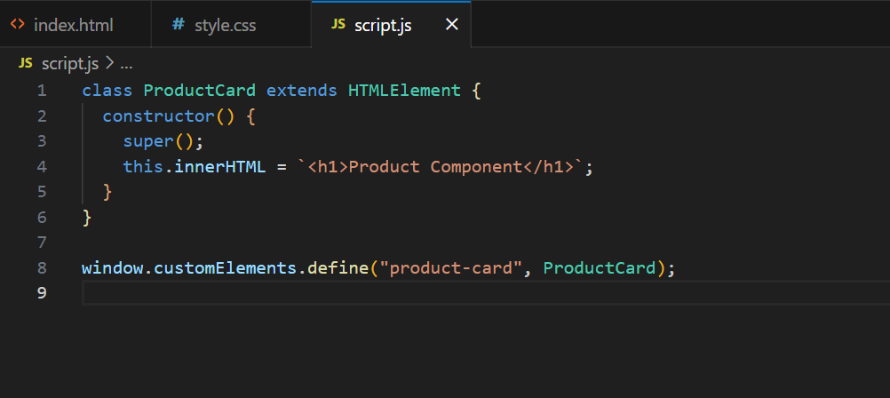

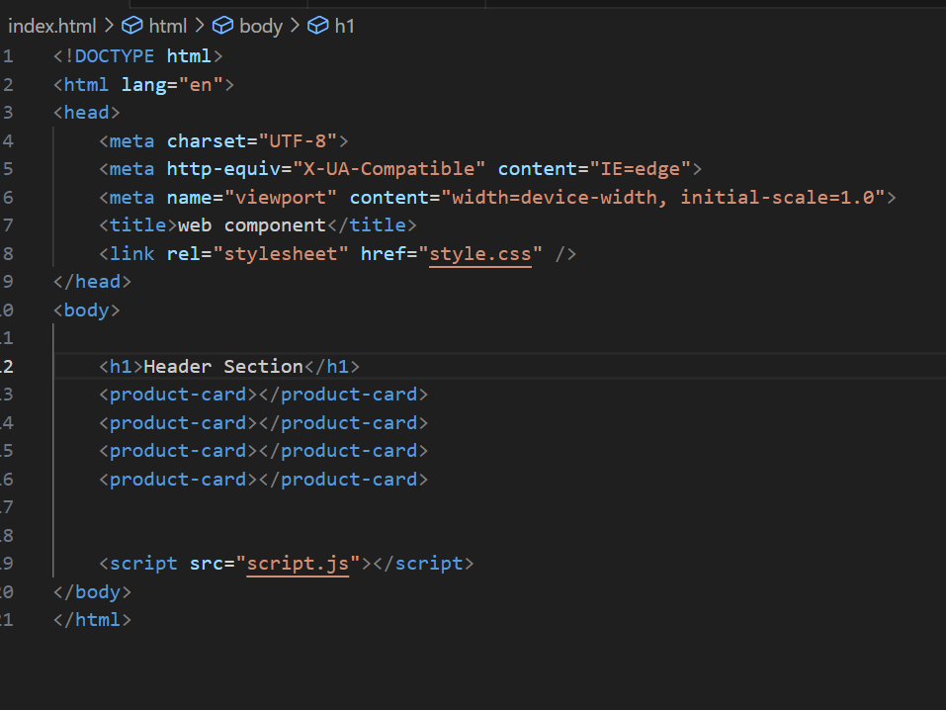

**Shadow DOM is a way to provide encapsulation to the web component or in the other words – shadow DOM is a way to provide a separate hidden DOM to web components i.e web component’s own DOM**

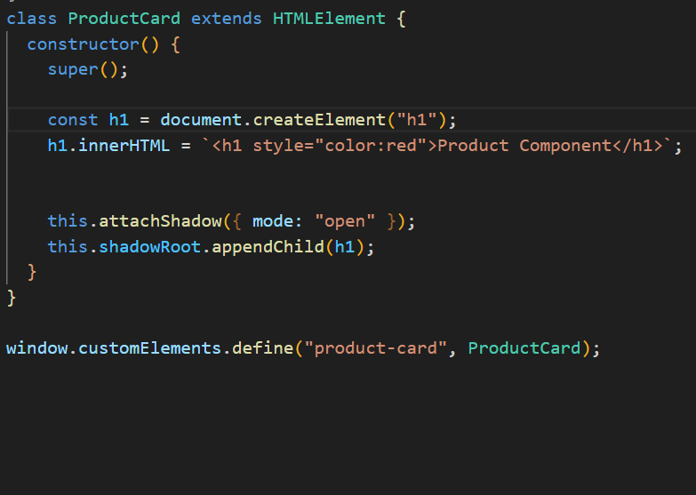

**The line this.attachShadow({mode:..}) and the line next to it will help us to add the element in the shadow DOM so that our element will have its own scope.**

**OOJS:**

**What is object literal?**

Simple key value pair is the object literal.

Let obj = {

pCode:100,

pName:’Apple’,

getData : function (){

console.log(pCode,pName);

}

}

**In ES6 instead of giving function like above we can simple give function like as follow:**

..

pName:’Apple’,

getData(){

console.log(pCode,pName);

}

**Important feature of ES6 in object is that we can have dynamic key:**

**How?**

**Let see with an example below:**

tmpVar = pCode;

let obj = {

[tmpVar] :100,

pName:’Apple’

}

**Here we’ve kept tmpVar in bracket, instead of taking tmpVar this will take the value that is assign to tmpVar i.e pCode.**

**Q.2) How can you add read-only properties to an object?**

Const proto = Object.defineProperty({},’pCode’,{

Writable:false,

Configurable:true,

Value:2001

});

Const obj = Object.create(proto);

Obj.pCode = 2001;

Console.log(obj.pCode);

**At first we’re defining an object with a pCode where we’re giving writing as false so that user couldn’t change the value of the key pCode later. In second we’re creating obj with the definition proto. We’re trying to change the value of the obj but this isn’t possible.**

**Q.3) What is property value short hand with object literal?**

Let pCode = 100;

Let pName = ‘Apple’;

Let obj = {

pCode,

pName

}**This is the property value short hand.**

**Q.5) How can we create a clone or separate copy of an object literal?**

let obj = {a:’first’};

let objCopy = Object.assign({},obj);

**This will create a separate copy of the obj in objCopy**

**If we change anything in objCopy that will not reflect in the obj.**

**THIS : this object doesn’t work with arrow function**

**Q.1) What will be the output of this code if you run in the browser and why?**

**function test(){**

**console.log(this);**

**}**

**test();**

**Q.2) What is the context of “this” inside arrow function? Or what will be the output of this code?**

**let obj={**

**test:()=>{**

**console.log(this);**

**}**

**}**

**obj.test();**

**it will show the window object.**

**Call, APPLY and Bind method:**

functionName.call(thisArg,arg1,arg2…);

function test(a,b){

console.log(this);

}

Let obj = {

a:5

}

This will print the window object, why, because it is referring to this inside the function. But what if we want to point “THIS” object to the obj.

Then we need to use “call”.

test.call(obj,5,6);

**Bind() is similar to call and also takes exact number of argument but the only difference is bind will not execute the function immediately rather it works as a function expression.**

**We need to collect it in a variable.**

**Let fe = test.bind(obj,5,6);**

**Fe();**

**All there, call, bind and apply changes the ref of an object.**

**Class, Class Expression and Static members:**

In ES5 we are using the constructor function to create a class whereas in ES6 we’re using the class keyword to create a function.

**In ES5 function used to act as a class as well.**

**Class test{**

**Constructor(){**

**Console.log(“Tesst..”);**

**}**

**}**

**Class expression:**

**Const test = class {**

**Constructor(){**

**Console.log(“I am the test..”);**

**}**

**}**

**const testtt = new test();**

**Inheriting, subclassing, and extending built in class.**

In ES6 we use extends keyword for inheriting the class.

**Class Child extends String{**

**}**

**Const obj = new Child(“Test string”);**

**Console.log(obj.toLowerCase());**

**To call the parent class method and use the parent class variable we make use of the super() constructor.**

1. **How can you inherit a class?**

**By using the extends keyword**

1. **How will you override the method?**

**By using the super()**

**Class Accessors – getter & setter methods**

class Vehicle{

set model(v){

console.log(“setter executed”);

}

Get model(v){

Console.log(“Getter executed”);

Return ‘’;

}

}

Const obj = new Vehicle();

Obj.model =’SUV’;

Console.log(obj.model);

Output:

Setter executed

Getter executed

**MAP:**

Let product = new Map();

Product.set(1,’Apple’);

.set(2,’orange’);

Loop:

**For(let v of product.values()){**

Console.log(v);

}

To get the keys

**For(let k of product.keys()){**

Console.log(k);

}

Now to get both the keys and values

**For(let [k,v] of product.entries()){**

**Console.log(`${k}-${v}`);**

**}**

**Convert the object literal into the Map:**

**Let obj = {**

**pCode:1001,**

**pName:’Orange’,**

**price:56**

**}**

**Let product = new Map(Object.entries(obj));**

**Console.log(product);**

**How to convert a map into the simple object?**

**We have to use Object.fromEntries();**

let product = new Map();

product.set(‘pCode’,1001)

.set(‘pName’,’Orange’)

.set(‘price’,56);

Let obj = Object.fromEntries(product.entries());

Console.log(obj);

**To know if something is in the map or not:**

Product.has(‘pCode’);

**Delete() method removes values by key and clear() method wipes out everything from the Map.**

Product.clear(), product.delete(‘pCode’)

**What are the advantages of using Map over Objects?**

Map keys can be value.

Keys are ordered, data insertion is ordered in Map.

Map has size property which returns number of key/values pair.

Map are iterable.

**How will you iterate through the map?**

By using the **Values(), keys() and entries() method. Like above example.**

**SET:**

Set collection or data structure doesn’t have keys, it has only values and that too unique values.

Let names = new Set();

Names.add(“first”);

.add(“second”);

Console.log(names);

Names.delete(“first”);

Names.clear();

**WeakMap and WeakSet**

**ASYNCHRONOUS JS:**

**Callback function:**

**Function fetchData(cb){**

**setTimeout(()=>{**

**let data ={pCode:1001,pName:’Orange’};**

**cb(data);**

**},2000);**

**}**

**fetchData(function(data){**

**console.log(data);**

**console.log(“Ends here”);**

**})**

**Function cSqr(n,cb){**

**setTimeout(()=>{**

**cb(n*n);**

**},2000)**

**}**

**cSqr(2,function(res){**

**console.log(res);**

**})**

**Callback hell or pyramid of Doom:**

**We have multiple callback : to solve this we have promises.**

**One call within another call is called callback hell.**

**Promise:**

**Syntax:**

**Let pr = new Promise((resolve,reject)=>{**

**Resolve();**

**})**

**Console.log(pr);**

Initially the status of promise will be something else than resolved. But when we put resolve() method in it, it will show us the resolve status.

We can put reject() as well.

**.then() and error handling.**

Let pr = new Promise((resolve,reject)=>{

Resolve(“success”);

})

Pr.then((msg)=>{

Console.log(msg);

}).catch((err)=>}{

Console.log(err);

}).finally(()=>{

Console.log(“Finishing process”);

})

Const cSqr= (a)=>{

Return new Promise((resolve,reject)=>{

setTimeout(()=>{

resolve(a*a);

},2000)

})

}

cSqr(2).then((res)=>{

console.log(res);

})

Earlier callback code in promise:

Function fetchData(){

Return new Promise((resolve,reject)=>{

setTimeout(()=>{

let data = {pCode:1001,pName:’orange’}

resolve(data)

},2000)

})

}

fetchData().then((data)=>{

console.log(data);

}).catch((err)=>{

Console.log(err);

}).finally(()=>{

Console.log(“always execute”);

})

cSqr(2).then((res)=>{

console.log(res);

return cSqr(res);

}).then((res1)=>{

Console.log(res1);

}).catch((err)=>{

Console.log(err);

})

**Promise.all() vs promise.allSettled() vs promise.race():**

Promise.all() : When you have a multiple promises as input it should return a single promise after all promises are resolved, then you can use the all().

For example there is a promise p1,p2 and p3:

Cosnt p1 = new Promise((resolve,reject)=>{

setTimeout(()=>{

resolve(“promise1”);

},2000)

});

**Just like this we have p2 and p3.**

**Now,**

**Promise.all([p1,p2,p3]).then((prMsgs)=>{**

**Console.log(prMsgs);**

**})**

**Output: [‘Promise1’,’Promise2’,’Promise3’]**

**What if promise1 state is in rejected then at that time promise.all() will show us an error for whole.**

**If we want to run the promise for the one whose state are in resolve make use of promise.allSettled() and promise.race() will execute the one which is faster.**

**ASYNC/ Await?**

Async/await handles promises, but with simple syntax.

By writing async function:

1. You don’t need to write a “return” statement
2. To return a “rejected” state, throw statement is written to reject a promise.

Async function test(){

}

Const test = async()=>{

Return 0;

}

.then() can be replace by the await.

In calling the square that we wrote up using .then will replace by await.

(Async function(){

Let res = await cSqr(2);

Console.log(res);

Let res1 = await cSqr(res);

Console.log(res1);

Let res2 = await cSqr(res1);

Console.log(res2);

})();

**AJAX & XMLHttpRequest:**

Ajax is about making an HTTP call to the webservices, API or REST API & that too without refreshing the entire page.

Javascript gives the Fetch API nowadays to make an AJAX call.

XMLHttpRequest object is replace by fetch() api nowadays.

Let request = new XMLHttpRequest();

Request.open(“GET”,”https://jsonplaceholder.typicode.com/comments”);

Request.responseType = ‘Json’;

Request.send();

Request.onLoad = function(){

If(request.status==200){

Console.log(request.response);

}else{

Console.log(Invalid request);

}

}

**Fetch() API: ES6 onwards**

**Const response = fetch(‘http://URL’ , {**

**Method: ‘POST’,**

**Headers: {**

**‘Content-Type’: ’application/json;charset=utf-8’**

**},**

**Body:JSON.stringify(data)**

**})**

**Aysnc function fetchData(){**

**Cosnt response = await fetch(“”);**

**Console.log(response);**

**If(response.ok){**

**Data = await response.json();**

**Console.log(data);**

**}**

**}**

**fetchData();**

**This can be simply as:**

**Fetch(“ ”).then(response=>response.json())**

**.then(data=> console.log(data));**

**How to make a POST request with this simplification:**

Const todo = {

userId:1001,

id:1,

title:’new title’,

completed:true

}

Fetch(‘https://jsonplaceholder.typicode.com/todos’,{

Method:’POST’,

Headers:{

‘content-type’:’application/json;charset=utf-8’

},

Body:JSON.stringify(todo);

}).then(response=>response);

**Async Iterators & Generators:**

This is related to [CoderDost Course on Advance JavaScript](https://www.youtube.com/watch?v=gUUCmRJjVvo)

# 1. Scope and Closure

* We have 3 types of variable in JavaScript ***var***, ***let*** and ***const***
* ☠️☠️ var is the old one, and should not be used now in any case. As it has many issues with creating scopes
  + why it is still there ?
* Also there are 4 kinds of scope in Javascript - Block Scope, Global Scope, Function Scope, Module Scope

## Block scope & Global Scope

The **scope** is the current context of execution in which values and expressions are "visible" [MDN](https://developer.mozilla.org/en-US/docs/Glossary/Scope)

**Global Scope** : Any variable/expression which is written outside - i.e. not inside any functions, blocks etc. This is shared across files.

### let

* this creates a block scope
* re-declaration in NOT allowed (in same scope)
* re-assignment is allowed

{ *// block scope*

let x = 0;

let y = 0;

console.log(x); *// 0*

let x = 1; *// Error*

}

{

let x = 1;

let y = 1;

x = 2;

console.log(x);*// 2*

}

console.log(x); *// Error in Global Scope*

**Temporal Dead Zone**(TDZ) : the area in which a variable is not accessible. Temporal because it depends on time of excution not position

{

*// TDZ starts*

const say = () => console.log(msg); *// hi*

let msg = 'hi';

say();

}

### const

* this creates a block scope
* re-declaration in NOT allowed
* re-assignment is NOT allowed
* must be assigned at declaration time.

{

const x; *//Error*

const y=0;

}

{

const x=1;

x=2 *// Error*

}

console.log(x); *// Error*

### Variable Shadowing

let x = 0 *// shadowed variable*

{

let x = 1;

console.log(x)

}

}

### var

* it doesn't have any block scope, and can be re-declared
* it only had function scope
* var are hoisted, so they can be used before the declaration

var x = 1;

var x = 2; *// valid*

console.log(y) *// valid*

var y = 3

z=4

console.log(z) *// valid*

var z;

**NOTE** : You should NOT use **var** now ❌

### let vs var

for(let i=0;i<5;i++){

setTimeout(

()=>console.log(i),

1000)

} *// prints 0,1,2,3,4*

for(var i=0;i<5;i++){

setTimeout(

()=>console.log(i),

1000)

} *// prints 5,5,5,5,5*

## Module scope

In modern javascript, a file can be considered as module, where we use export and import syntax to use variable across files. We

<script src="index.js" type="module"></script>

export { someVar, someFunc}

import { someVar} from './app.js'

### global Object

* The global Object is the variable **window** in case of browser. This helps you to use variables across the scopes. Also, it is the **this** value for global functions
  + window.alert
  + window.Promise
* In non-browser environment, **window** doesn't exist. but other global objects exist.
* ***var*** affects this global obejct, also ***function*** declarations.

function sayHi(){

console.log(this) *// this will refer to window*

}

*// Strict mode can change this behaviour;*

`use strict`

function sayHi(){

console.log(window) *// this is a better way of code*

}

## function scope

* it is created upon execution a function

function sayHi(name){

return name;

}

sayHi() *// this call will create a function scope*

sayHi() *// this call will create another function scope*

#### Lexical Environment

* Every variable in JavaScript (within global / block / or function) has a reference to an object-like data called Lexical enviroment. This object (kind of object) serves as the basis of search for value of variable.

let name = 'john'

console.log(name)

[outer]

null

LexicalEnviroment

name: 'john'

name

Lexical Enviroment (Global variable)

let name = 'john';

function sayHi(){

let greet = "hi"

console.log(greet)

}

sayHi()

console.log(name, sayHi)

[outer]

[outer]

null

LexicalEnviroment1

name: 'john',

sayHi: function

LexicalEnviroment2

greet: 'hi'

name

sayHi

greet

Lexical Enviroment (functions)

let name = 'john';

function sayHi(){

let greet = "hi"

console.log(name)

}

sayHi()

[outer]

[outer]

null

LexicalEnviroment1

name: 'john',

sayHi: function

LexicalEnviroment2

greet: 'hi'

name

Lexical Enviroment (functions)

## Hoisting

The movement of variable declaration to top of scope - before execution

* function declarations are properly hoisted (value accessible)
* var is hoisted.

let name = 'john';

sayHi() *// valid*

function sayHi(){

let greet = "hi"

console.log(name)

}

sayHello() *// error*

let sayHello = function(){

console.log(name)

}

**Temporal Dead Zone**(TDZ) :

let x = 1;

{

console.log(x) *// Reference error*

let x = 2;

}

## Closures

* we can create nested functions in JavaScript

function createUser(name){

let greeting = 'Hi '

function greet(){

return greeting + name + ' is Created';

}

return greet()

}

createUser('john') *// Hi john is created;*

* Now more useful work is if we can return the greet function itself.

function createUser(name){

let greeting = 'Hi '

function greet(){

return greeting + name + ' is Created';

}

return greet *// returned just definition of function*

}

let welcomeJohn = createUser('john')

welcomeJohn() *// // Hi john is created;*

* This is **Closure**
  + welcomeJohn function definition has access
    - to outer **params** ( name ) which came for createUser function
    - also any other "variables" declared inside createUser will also be accessible to this welcomeJohn

### Example

function initCounter() {

let count = 0;

return function () {

count++;

};

}

let counter = initCounter();

counter() *// 0*

counter() *// 1*

let counter1 = initCounter();

counter1() *// 0*

counter1() *// 1*

**NOTE** : so whenever you have a function which wants to preserve a value over many calls - it's a time for closure.

#### Lexical Environment

function init() {

let name = 'john';

function greet() {

console.log(name)

}

return greet;

}

let sayHi = init();

sayHi();

[outer]

[outer]

[outer]

null

LexicalEnviroment1

sayHi: ----

init: function

LexicalEnviroment2

name: 'john'

greet: function

LexicalEnviroment3

--empty--

init

name

sayHi

Lexical Enviroment (functions)

### Real life example 1

function initCounter(id) {

let count = 0;

return function () {

count++;

document.getElementById(id).innerText = count;

};

}

let count = 10;

let counter1 = initCounter('btnCount1');

let counter2 = initCounter('btnCount2');

*// here `btn1` and `btn2` are id of HTML buttons.*

<button onclick="counter1()">1</button>

<p id="btnCount1"></p>

<button onclick="counter2()">2</button>

<p id="btnCount2"></p>

### Real life example 2

function initAddString(inputId, outputId) {

let str = '';

return function () {

str += ' ' + document.getElementById(inputId).value;

document.getElementById(inputId).value = '';

document.getElementById(outputId).innerText = str;

};

}

let strAdder1 = initAddString('text1', 'text-output1');

let strAdder2 = initAddString('text2', 'text-output2');

<input type="text" id="text1">

<button onclick="strAdder1()">Add String</button>

<p id="text-output1"></p>

<input type="text" id="text2">

<button onclick="strAdder2()">Add String</button>

<p id="text-output2"></p>

## IIFE - Immediately Invoked Function Expression

* this practice was popular due to var.
* Immediately invoking a function avoids - re-declaration of variables inside it

*// Immediately invoked function expressions*

(function(){

var x = 1; *// this var is now protected*

})()

(function(a){

var x = a; *// this var is now protected*

})(2)

## Currying

function sum(a){

return function(b){

return function(c){

console.log(a,b,c)

return a+b+c

}

}

}

let add = a => b => c => a+b+c

let log = time => type => msg => `At ${time.toLocaleString()}: severity ${type} => ${msg}`

log(new Date())('error')('power not sufficient')

let logNow = log(new Date())

logNow('warning')('temp high')

let logErrorNow = log(new Date())('error')

logErrorNow('unknown error')

function op(operation) {

return function (a) {

return function (b) {

return operation === 'add' ? a + b : a - b;

};

};

}

const add3 = op('add')(3);

const sub3 = op('sub')(3);

const add = op('add');

add3(6);

sub3(6);

add(1)(2);

# 2. Objects

## Basic behaviours

### Reference Copying

* Variable value is not copied in case of object/arrays

let person = {name:'john'}

let human = person;

person

Object

human

Reference are point to same value

let person = {name:'john'} *// Object1*

person = {name:'wick'}; *// Object2*

person

Object1

Object2

Reference can be changed for a variable (Garbage collection of Object1)

* it a better to use const always, and whenever you must need to re-assign change it ot let

const person = {name:'john'} *// Object1*

person = {name:'wick'}; *// ERROR*

### Nested Objects

let person = {

name: 'John',

address: { city: 'delhi', state: 'delhi' },

};

person

Object

Object_address

addressObject

Object properties can point to other objects

let addressObject = { city: 'delhi', state: 'delhi' }

let person = {

name: 'John',

address: addressObject

};

### Copying objects

#### Shallow Copy

Many methods can be used to copy object without old reference

1. **Object.assign()**

let person = {name:'john'}

let newPerson = Object.assign({}, person)

1. **Spread Operator[...]**

let person = {name:'john'}

let newPerson = {...person}

But problem which these is they just create a copy of properties of that object , but not creating a copy of their references also.

let addressObject = { city: 'delhi', state: 'delhi' }

let person = {

name: 'John',

address: addressObject

};

let newPerson = Object.assign({}, person)

person === newPerson; *// false*

person.address === newPerson.address *// true*

#### Deep Copy

This is a hard problem to solve in past as there can be multiple level of nested objects and there can be references to functions etc also. few methods which are there:

1. **JSON.stringify and JSON.parse** : this method utilizes the fact that every JSON can be converted to a string value (exception of methods/functions)

let addressObject = { city: 'delhi', state: 'delhi' }

let person = {

name: 'John',

address: addressObject

};

let str = JSON.stringify(person)

let jsonObject = JSON.parse(str);

1. **structuredClone** : Browser API which work even for circular references (but functions not supported)

let addressObject = { city: 'delhi', state: 'delhi' }

let person = {

name: 'John',

address: addressObject,

};

person.me = person

let newPerson = structuredClone(person);

### "this" and Methods

* we can also defined function as value to properties of objecy. these will be called methods. Methods are just functions but, it means they have been called in "reference" on an Object.

let person = {

name:'john',

sayHi: function(){

return "hi";

}

}

person.sayHi() *// hi*

* methods can also access the properties and other methods of same object. To do this we use this

let person = {

name:'john',

sayHi: function(){

return "hi "+ this.name;

}

}

person.sayHi() *// hi john*

* we can also have used person instead of this but has you know references can be changed. so that could have created a problem

let person = {

name:'john',

sayHi: function(){

return "hi "+ this.name;

}

}

person.sayHi() *// hi john*

* you can even have this without an object

function sayHi(){

return "hi "+ this.name;

}

sayHi() *// Error*

*// here this will "undefined" in Strict mode*

let obj1 = {name: 'john'}

let obj2 = {name: 'wick'}

*// you can add functional property*

obj1.say = sayHi;

obj2.say = sayHi;

obj1.say() *// hi john*

obj2.say() *// hi wick*

* Arrow functions don't have a this. they use outer context

let person = {

name:'john',

sayHi: ()=> {

return "hi "+ this.name;

}

}

person.sayHi() *// Error*

## Symbol

* JavaScript also has a Symbol data type. This data type is used as property name in Objects.
* Object can only have 2 types of properties - String and Symbol. If you put any other data type they will convert to String

let person = {

0:'john',

sayHi: ()=> {

return "hi "+ this.name;

}

}

person["0"] *// this number will convert to string*

* Symbol is used for making hidden (library used properties)

const id = Symbol("id"); *// "id" is descriptor*

let person = {

name:'john',

[id]:1

}

person[id] *// 1*

*// note that we have put square [] on property so that it is not confused with "id" string.*

* Symbol are always unique - so there is no chance of collision. Even with same "descriptor" they will be uniquely initialized.
* You can get Symbol for some descriptor or key using some methods

*// get symbol by name*

let sym = Symbol.for("name");

let sym2 = Symbol.for("id");

for..in loop ignore Symbols. Also methods like Object.keys() ignore these properties.

# 3. Functions

## functions are objects

* they already have some predefined properties name, length etc
* you can also make more properties on functions (but generally it's not required, except for Constructor function)

function sayHi(greet){

return greet

}

sayHi.name *// name of function*

sayHi.length *// length of arguments*

sayHi.count =0; *// function can have properties*

sayHi.count++;

sayHi.count;

## function declaration are hoisted

sayHi() *// works*

function sayHi(greet){

return greet

}

sayHello() *// Error*

let sayHello = function(){ *// functional expression*

}

sayHello.name *// sayHello*

## function can be called as constructor

function Person(name){

this.name = name

}

const p = new Person('john') *// constructor*

## Named function expression (NFE)

let sayHello = function fx(user){ *// named functional expression*

if(user){

return "hello " + user

} else {

return fx('anonymous')

}

}

*// this can help in case where sayHello is re-assiged to something*

let sayHi = sayHello

sayHello = null

sayHi()

## Decorator (Wrappers)

* It's a design pattern in which you modify the functionality of a function by covering it inside a wrapper.

let modifiedFx = Decorator(preDefinedFx)

### Memoization (Caching)

function heavy(x) {

console.log(x + ':heavy');

return x + ':heavy';

}

function memoized(fx) {

let map = new Map();

return function (x) { *// wrapper*

if (map.has(x)) {

return map.get(x);

} else {

let memoValue = fx(x);

map.set(x, memoValue);

return memoValue;

}

};

}

let memoizedHeavy = memoized(heavy)

memoizedHeavy(2);

memoizedHeavy(2); *// take from cache*

**Another Problem**

* if you try to use this on a method of object, this approach can fail

let task = {

name: 'demo',

heavy(x) {

console.log(x + ':heavy:' + this.name);

return x + ':heavy' + this.name;

},

};

function memoized(fx) {

let map = new Map();

return function (x) {

if (map.has(x)) {

return map.get(x);

} else {

let memoValue = fx(x);

map.set(x, memoValue);

return memoValue;

}

};

}

task.memoizedHeavy = memoized(task.heavy)

task.memoizedHeavy(1) *// 1:heavyundefined*

**Solution** : use function.call()

### changing 'this'

###### Call

person = {

name: 'demo',

age: 12,

location: 'delhi',

};

function checkName(a) {

return !!this.name;

}

checkName() *// Error*

checkName.call(person)

checkName.call(person, 1) *// a = 1*

###### apply

person = {

name: 'demo',

age: 12,

location: 'delhi',

};

function checkName(a) {

return !!this.name;

}

checkName() *// Error*

checkName.apply(person)

checkName.apply(person, [1]) *// a = 1*

###### bind

person = {

name: 'demo',

age: 12,

location: 'delhi',

};

function checkName(a) {

return !!this.name;

}

checkName() *// Error*

let boundCheckName = checkName.bind(person)

boundCheckName();

**Solution**

let task = {

name: 'demo',

heavy(x) {

console.log(x + ':heavy:' + this.name);

return x + ':heavy' + this.name;

},

};

function memoized(fx) {

let map = new Map();

return function (x) {

if (map.has(x)) {

return map.get(x);

} else {

let memoValue = fx.call(this,x);

map.set(x, memoValue);

return memoValue;

}

};

}

task.memoizedHeavy = memoized(task.heavy)

task.memoizedHeavy(1) *// 1:heavydemo*

### Debounce

* Run a function only when - if it has not been called again for a fixed period
* Suppose you are typing and take a pause of 1 second. Only then that function should be called.

let count = 1;

function showCount() {

count++;

console.log({ count });

}

function debounce(fx, time) {

let id = null;

return function (x) {

if (id) {

clearTimeout(id);

}

console.log({ id });

id = setTimeout(() => {

fx(x);

id = null;

}, time);

};

}

let showCountD = debounce(showCount, 2000);

setTimeout(showCountD, 1000);

setTimeout(showCountD, 1500);

setTimeout(showCountD, 2000);

setTimeout(showCountD, 2500);

setTimeout(showCountD, 5000);

##### Real Example

const el = document.getElementById('text1');

const logo = document.getElementById('text-output1');

el.addEventListener(

'keyup',

debounce(function (e) {

logo.innerText = e.target.value;

}, 1000)

);

<input type="text" id="text1">

<p id="text-output1"></p>

#### Throttle

* when you have to only allow 1 execution of a function within a period of time
* for example you are scrolling fast but only 1 scroll per 100 millisecond is considered.

let count = 1;

function showCount() {

count++;

console.log({ count });

}

function throttle(fx, time) {

let id = null;

let arg = [];

return function (x) {

arg[0] = x;

if (!id) {

id = setTimeout(() => {

fx(arg[0]);

id = null;

}, time);

}

console.log({ id });

};

}

let showCountT = throttle(showCount, 2000);

setTimeout(showCountT, 1000);

setTimeout(showCountT, 1500);

setTimeout(showCountT, 2000);

setTimeout(showCountT, 2500);

setTimeout(showCountT, 5000);

##### Real Example

function throttle(fx, time) {

let id = null;

let arg = [];

return function (x) {

arg[0] = x;

if (!id) {

id = setTimeout(() => {

fx(arg[0]);

id = null;

}, time);

}

};

}

function sayHi(){console.log('hi')}

document.addEventListener('scroll',throttle(sayHi,1000))

## Arrow functions

#### Differences

* they don't have this
* they don't have arguments,
* they can't be called with new (as constructor)

#### Similarities

* they have properties like name, length

# 4. Iterables, Generators

## Iterables and Iterators

### Iterable (protocol)

* Iterables are objects in which we can make array like iteration (Example using for..of loop of spread operators)
  + Array are iterables
  + String are iterables
* To make any object iterable we have these conditions
  + implement a Symbol.iterator property, which should be a function which return an Iterator Object

iterable[Symbol.iterator]() => Iterator

### Iterator (protocol)

Iterators are objects which have :

* a next() method which return a object which is of format {value:-some-value-, done:-boolean-} e.g. *{value: 1, done: false}
* **value** is the value we are interested in, while **done** tells us when to stop. Generally when done:true the value:undefined

Now, making an Iterable is like this:

let iterator = {

i: 0,

next: function () {

return { value: this.i, done: this.i++ > 5 };

},

};

let iterable = {

name: 'john',

age: 34,

[Symbol.iterator]() {

return iterator;

},

};

#### Example - Range :

let range = {

start: 0,

end: 5,

[Symbol.iterator]() {

let that = this; *// this line is very important*

let i = this.start;

return { *// iterator object*

next: function () {

return { value: i, done: i++ > that.end };

}

};

},

};

#### Array

let num = [1, 2, 3];

let iterator = num[Symbol.iterator]();

iterator.next();

iterator.next();

iterator.next();

iterator.next();

## Infinite iterators

* As we can see that we can control, how to control the next() function. In few cases, it will be useful to have iterators which can need to generate the next value infinitely
* If you use such iterators in a loop etc. it can be dangerous as can create infinite loop. But can be controlled by break etc.
* we will cover all this in generators.

## Iterables vs Array-like

* Iterable objects are based on Symbol.iterator method as defined above
* Array-like objects are based on array protocols (index and length)

An object can be

* Iterable + Array-like
* Iterable only
* Array-like only
* None of them (not Iterable nor Array-like )

**Example** :

*// iterable + array-like*

let arr = [1,2,3]

*// only iterable*

let range = {

start: 0,

end: 5,

[Symbol.iterator]() {

let that = this; *// this line is very important*

let i = this.start;

return {

next: function () {

return { value: i, done: i++ > that.end };

},

};

},

};

*// only array-like*

let array = {

0: 1,

1: 5,

length:2

};

*// none*

let obj = {

name:'john'

}

### Conversions

#### Array-like to Array

* **Array.from()** : method is used for this

let arrayLike = {

0: 0,

1: 5,

length: 2

};

let arr = Array.from(arrayLike);

*// also used for general things*

let set = new Set()

set.add(1);

set.add(2);

let arr2 = Array.from(set) *// [1,2]*

## Map

* this data type is also iterable
* special this is can have keys also as numbers, booleans, objects
* also map maintains the order of keys added.

let map = new Map();

let person = {name:'john'}

let personAccount = {balance: 5000}

map.set('1', 'str1'); *// string key*

map.set(1, 'num1'); *// numeric key*

map.set(true, 'bool1');

map.set (person, personAccount)

map.get(1) *// 'num1'*

map.get('1') *// 'str1'*

map.get(person) *// { balance : 5000 }*

map.size *// 4*

map.keys() *// iterable of keys*

map.values() *// iterable of values*

map.entries() *// iterable of key-value pair*

map.has(1) *// key exists*

#### Converting Object to Map

* We can use **Object.entries()** method for this.

let obj = {a:1,b:2,c:3};

let map = new Map(Object.entries(obj));

#### Converting Map to Object

* We can use **Object.fromEntries()** method for this.

let map = new Map();

map.set('a', 1);

map.set('b', 2);

map.set('c', 3);

let obj = (Object.fromEntries(map.entries())); *// {a:1,b:2,c:3}*

## Set

* Set is another iterable
* Set only contains uniques elements

let set = new Set();

let obj1 = { name: "John" };

let obj2 = { name: "Jack" };

let obj3 = { name: "Peter" };

set.add(obj1);

set.add(obj2);

set.add(obj3);

set.add(obj2);

set.add(obj3);

*// set keeps only unique values*

set.size; *// 3*

set.keys() *// iterable of keys*

set.values() *// iterable of values (Same as keys)*

set.entries()

* duplicated values in values(), entries() etc are maintained to match Map compatibility

## WeakMap and Weakset

* These are 2 alternative way of creating Map or Set like data types - when only object keys are considered.
* They have very limited operations and doesn't support all functionality
* Main purpose is that when keys are marked as null they are garbage collected. So this helps in better memory management

let weakMap = new WeakMap()

let person = {name:'john'}

weakMap.set(person, {....});

person = null *// in future we decide to remove this key*

*// so weakMap will remove it from memory space automatically*

## Generators

* Easy way to create an iterators and iterables

function* generatorFunction(){

yield 1;

yield 2;

yield 3

}

let generator = generatorFunction();

generator.next() *// {value:1, done:false}*

generator.next() *// {value:2, done:false}*

generator.next() *// {value:3, done:false}*

generator.next() *// {done:true}*

#### Infinite iterator

function* generator() {

let i = 0;

while (true) {

yield i;

i++;

}

}

const gen = generator();

function createID(it) {

return it.next().value;

}

createID(gen);

createID(gen);

createID(gen);

createID(gen);

createID(gen);

#### Generator objects are "iterables"

function* generatorFunction(){

yield 1;

yield 2;

yield 3

}

let generator = generatorFunction();

let nums = [...generator] *// [1,2,3]*

**NOTE**: Don't put a Spread operator or for..of loop on inifinite iterable

#### Range example - using generator

let range = {

start: 0,

end: 5,

*[Symbol.iterator]() { *// * makes it generator function*

for(let value = this.start; value <= this.end; value++) {

yield value;

}

}

};

for(let r of range){

console.log(r)

}

**Better version - with function**

function range(start,end){

return {

*[Symbol.iterator]() {

for(let value = start; value <= end; value++) {

yield value;

}

}

}

};

for(let r of range(1,5)){

console.log(r)

}

let values = [...range(1,5)]

**Better - Better version - with function**

function* range(start,end){

for(let value = start; value <= end; value++) {

yield value;

}

};

let generator = range(1,5)

console.log([...generator]) *// [1,2,3,4,5]*

### return

* only difference it that instantly ends the iterator at that value;

function* generatorFunction(){

yield 1;

yield 2;

return 3

}

let generator = generatorFunction();

generator.next() *// {value:1, done:false}*

generator.next() *// {value:2, done:false}*

generator.next() *// {value:3, done:true} \*\**

### Generator - composition

* using generator inside another generator is easy

**Composed Generator using - yield*

function* range(start,end){

for(let value = start; value <= end; value++) {

yield value;

}

};

function* multiRange(){

yield* range(0,5),

yield* range(100,105)

yield* range(200,205)

}

let generator = multiRange();

console.log([...generator]) *//[ 0, 1, 2, 3, 4, 5, 100, 101, 102, 103, 104, 105, 200, 201, 202, 203, 204, 205 ]*

### Generator can also take inputs

* **next()** method can also take arguments which act as return value of previous yield statement

function* generatorFunction(){

let result = yield 1;

console.log(result)

let result2 = yield 2;

console.log(result2)

let result3 = yield 3

console.log(result3)

}

let generator = generatorFunction();

let r1 = generator.next()

let r2 = generator.next(r1.value)

let r3 = generator.next(r2.value)

generator.next(r3.value)

## Async Iterators/ Async generators

**without generators**

let range = {

start: 0,

end: 5,

[Symbol.asyncIterator]() {

let that = this; *// this line is very important*

let i = this.start;

return {

next: async function () {

await new Promise((resolve) => setTimeout(resolve, 1000));

return { value: i, done: i++ > that.end };

},

};

},

};

(async function () {

for await (let f of range) {

console.log(f);

}

})();

**with generators**

let range = {

start: 0,

end: 5,

async *[Symbol.asyncIterator]() {

for(let i = this.start; i <= this.end; i++) {

await new Promise((resolve) => setTimeout(resolve, 1000));

yield i

};

},

};

(async function () {

for await (let f of range) {

console.log(f);

}

})();

### Real-life Example - Paginated API calls

* this example has also used Composition of generators

async function* getDataAsync(page) {

let response = await fetch(

'https://projects.propublica.org/nonprofits/api/v2/search.json?q=x&page='+page

);

let result = await response.json();

for(let org of result.organizations){

yield org.name;

}

}

async function* getData() {

let response = await fetch(

'https://projects.propublica.org/nonprofits/api/v2/search.json?q=x'

);

let result = await response.json();

for (let i = 0; i <= result.num_pages; i++) {

yield* await getDataAsync(i);

}

}

(async function () {

let orgs = []

for await (let f of getData()) {

orgs.push(f);

}

console.log(orgs); *// List of all organization in API*

})();

# 5. ProtoTypes

## Prototypical Inheritance

* Objects are extended from other Objects. And we can re-use their properties and methods.
* Object are chained in prototypical inheritance
* Objects have a hidden property called [[Prototype]]

[[prototype]]

prototypeObject

object

Prototype Inheritance

[[prototype]]

animal

eats

dog

barks

animal is prototype of dog

dog is  
prototypically inherited  
from animal

Prototype example

let animal = { eats: true };

let dog = { barks: true };

dog.__proto__ = animal;

dog.barks *// true*

dog.eats *// true*

[[prototype]]

animal

eats

walks()

dog

barks

Prototype chaining

let animal = {

eats: true,

walks: function () {

return 'walks';

},

};

let dog = { barks: true };

dog.__proto__ = animal;

dog.walks() *// walks*

[[prototype]]

[[prototype]]

animal

eats

walks()

dog

barks

myDog

name

Prototype chain can be longer and longer

let animal = {

eats: true,

walks: function () {

return 'walks';

},

};

let dog = { barks: true };

let myDog = { name: 'sifu' };

dog.__proto__ = animal;

myDog.__proto__ = dog;

myDog.name *// sifu*

myDog.barks *// true*

myDog.walks() *// walks*

[[prototype]]

[[prototype]]

null

Object_prototype

animal

eats

walks()

dog

barks

myDog

name

Prototype end at "null"

## __proto__

* __proto__ is a getter/setter for [[Prototype]]
* Writing property, doesn't call inherited properties. Except for getter/setter properties.
* __proto__ is not used now , and recommended way is to use Object.getPrototypeOf() and Object.setPrototypeOf

let animal = {

eats: true,

walks: function () {

return 'walks';

},

};

let dog = { barks: true };

let myDog = { name: 'sifu' };

dog.__proto__ = animal;

myDog.__proto__ = dog;

myDog.walks = function(){

return 'walks slowly'; *// this will not affect prototype*

}

myDog.walks() *// walks slowly*

dog.walks() *// walks*

* for..in loop works on all properties which are enumerable - inherited or own
* if you want to avoid looping on inherited ones use Object.hasOwn or Object.prototype.hasOwnProperty
* Object.keys() and Object.value() these will avoid inherited properties.

## .prototype property, constructor

### properties

*// simple object initialization*

let usr = {

name : 'john'

}

*// now using a constructor function*

function User(name){

this.name = name

}

let user = new User('john');

console.log(user)

*// User{ name : 'john'}*

console.log(usr)

*// {name : 'john'}*

* Step 1 : **.prototype** proptery is automatically created (on User) and is assigned an object (empty Object)

function User(name){

this.name = name

}

let user = new User('john');

console.log(User.prototype) *// prototype object*

* Step 2 :**constructor** method is assigned to this prototype, and that is User function itself.

*// User.prototype.constructor = User*

*// this above assignment is done by the constructor call itself*

User.prototype.constructor === User *// true*

* Step 3: **.prototype** property's object is assigned to created instances.

*// user.__proto__ = User.prototype*

*// this above assignment is done by the constructor call itself*

user.__proto__ === User.prototype *// true*

[[prototype]]

User

prototype

User_prototype

constructor

user

name

.prototype property

### methods

function User(name){

this.name = name

}

User.prototype.sayHi = function () {

return this.name;

};

let user = new User('john');

let user1 = new User('wick');

user.sayHi()

*// 'john'*

user1.sayHi();

*// 'wick'*

* this the main benefit of prototypes. you can have inherited methods.

[[prototype]]

User

prototype

User_prototype

constructor

sayHi

user

name

.prototype property

#### A useful method : reverseString

### methods

function User(name){

this.name = name

}

User.prototype.reverseName = function () {

return this.name.split('').reverse().join('');

};

let user = new User('john');

let user1 = new User('wick');

user.reverseName()

*// 'nhoj'*

user1.reverseName();

*// 'kicw'*

* remember prototype based methods are directly available on their created object instances.
* you can also change the prototype completely, not recommended though

let animal = {

eats: true,

walks: function () {

return 'walks';

},

};

function Dog(){

this.barks = true

}

Dog.prototype = animal;

let dog = new Dog();

dog.walks()

*// walks*

dog.__proto__ === animal; *// true*

Dog.prototype === dog.__proto__ *// true*

[[prototype]]

Dog

prototype

animal

eats

walks()

dog

barks

.prototype property

## Native Prototypes

* Object.prototype
* Array.prototype
* Function.prototype

### Object.prototype

let obj = {}

let obj1 = new Object();

Object.prototype === obj1.__proto__ *// true*

Object.prototype === obj.__proto__ *// true*

* toString()
* isPrototypeOf()
* toLocaleString()

### Array.prototype

let arr = []

let arr1 = new Array();

Array.prototype === arr1.__proto__ *// true*

Array.prototype === arr.__proto__ *// true*

* push()
* pop()
* slice()
* splice()
* reverse()
* ....and many more

### Function.prototype

function Fx(){

}

Function.prototype === Fx.__proto__ *// true*

* call()
* apply()
* bind()
* arguments
* caller
* length

### Date.prototype

let d = new Date();

d.getTime(); *// getTime is given by Date.prototype*

* getTime()
* getDay()
* getDate()
* .... more

## Primitives

Primitive types also get wrapped into a Object when used as an Object

### String.prototype

"hello".toString()

### Number.prototype

10.1111.toFixed(2)

### Boolean.prototype

## Polyfills

* polyfill is a way of providing futuristic API not available in browser.
* polyfills are made often Native prototype modifications, so that we can get a feature/API (which is not available in current browser)
* This can help us write code / libraries which can run on many systems (old or modern)

if(!Array.prototype.contains){

Array.prototype.contains = function(searchElement) {

return this.indexOf(searchElement)>=0 ? true : false

}

}

*// similar to includes()*

**NOTE** : Shims are piece of code to correct some existing behaviour, while Polyfills are new API/ behaviours.

## Static properties and methods

Some properties and methods are directly created on these Native constructors.

* **Object.create()**
* **Object.keys()**
* **Object.values()**
* **Object.hasOwn()**
* **Array.from()**
* **Date.now()**

These are not available on instances, and only available on Native contructors

# 6. Class

Classes are easier way to implement inheritance in JavaScript.

## Syntactic Sugar

It's a syntactic sugar to Protypical Inheritance BUT more functionalities than it.

ProtoType Version

function User(name){

this.name = name

}

User.prototype.sayHi = function () {

return this.name;

};

let user = new User('john');

user.sayHi() *// john*

Class Version

class User {

constructor(name) {

this.name = name;

}

sayHi() {

return this.name;

}

}

let user = new User('john');

user.sayHi() *// john*

### Similarities:

1. Same kind of prototype property with constructor method is added when called with new;
2. you can use prototype also on class based things

class User {

constructor(name) {

this.name = name;

}

sayHi() {

return this.name;

}

}

User.prototype.sayHello = function(){

return "hello "+this.name;

}

let user = new User('john');

user.sayHello() *// hello john*

### Differences:

1. Class methods are non-enumerable
2. Class toString() is different
3. Class can only be called with new . Not as a normal function
4. Class is always is use strict mode.

## getter/setters

* Accessor properties can also be used in class

class User {

constructor(firstName, lastName) {

this.firstName = firstName;

this.lastName = lastName;

}

get fullName(){

return this.firstName + ' ' + this.lastName;

}

set fullName(_fullName){

this.firstName = _fullName.split(' ')[0];

this.lastName = _fullName.split(' ')[1];

}

}

let user = new User('john', 'wick');

user.fullName *// john wick*

user.fullName = "john cena"

user.firstName *// john*

user.lastName *// cena*

## Computed property names

* properties which don't have a fixed name and assigned by [ ]

let variableName = "hello"

class User {

constructor(name) {

this.name = name;

}

[variableName]() {

return this.name;

}

}

let user = new User('john');

user.hello() *// john```*

## "this" binding issue

class Button {

constructor(value) {

this.value = value;

}

click() {

return this.value;

}

}

let button = new Button("play");

button.click() *// play*

setTimeout(button.click, 1000);

*// this has issue - this has changed here*

* here we lose the context of this.

**2 Solution exists :**

1. Arrow functions : use arrow function wrappers.

setTimeout(()=>button.click(), 1000);

1. use .bind() to constructor object.

setTimeout(button.click.bind(button), 1000);

Also you can add this **arrow** style function in class definition - which will act as class field

class Button {

constructor(value) {

this.value = value;

}

click = () => { *// this is a class field*

return this.value;

}

}

let button = new Button("play");

button.click() *// play*

setTimeout(button.click, 1000);

## Inheritance

* We can inherit Parent Class properties and metods in a Child Class. using extends keyword
* Here we have ***Shape*** as Parent and ***Rectangle*** as Child :

class Shape {

constructor(name) {

this.name = name;

}

displayShape() {

return 'Shape ' + this.name;

}

}

class Rectangle extends Shape {

}

let rect1 = new Rectangle('rect1');

rect1.displayShape(); *// Shape rect1*

*// constructor of Child is implicitly created and it calls constructor of Parent*

*// constructor(...args){*

*// super(..args)*

*// }*

[[prototype]]

[[prototype]]

Shape

prototype

Shape_prototype

constructor

name

displayName

Rectangle_prototype

constructor

rect1

Rectangle

prototype

.prototype property

* Now adding more properties to constructor of Rectangle. You have to call super constructor - which will call Shape constructor.

class Shape {

constructor(name) {

this.name = name;

}

displayShape() {

return 'Shape ' + this.name;

}

}

class Rectangle extends Shape {

constructor(name, width, height) {

super(name);

this.width = width;

this.height = height;

this.area = width * height;

}

}

let rect1 = new Rectangle('rect1', 10, 11);

rect1.displayShape();

rect1.area;

## Static Methods

* We can have methods on constructor function also.
* These methods are called static methods and they don't apply on prototype. So they are not accessible to created objects also.
* Use of such methods is limited to Class wide applications
* this remains same as the class

class Shape {

constructor(name,area) {

this.name = name;

this.area = area;

}

static areEqual(shape1, shape2){

return shape1.name === shape2.name && shape1.area === shape2.area

}

}

let s1 = new Shape('rectangle',100)

let s2 = new Shape('rectangle',100)

Shape.areEqual(s1,s2) *// true*

* static property are also available as a new feature, but rarely used.

## Private and Protected properties

* in Object Oriented Programming there is a concept of Encapsulation or Data Hiding - so that you just interact with object via given methods/properties. This avoids changing some internal properties which are not meant for public use.

class User {

type = "admin"

constructor(name) {

this.name = name;

}

}

let user = new User('john')

user.type = "normal"

* properties type and name both are accessible - so they are called public

### Protected

* this is something not provided by javascript but by convention and get/set method we can create it
* you have to use convention of _ in front of property name - making is known to developer that this property is not directly accessible and used only via get/set accessors.

class User {

_type = "admin"

constructor(name) {

this.name = name;

}

get type(){

return this._type

}

set type(type){

this._type = type;

}

}

let user = new User('john')

user.type = "normal"

But what is benefit ?

class User {

_type = "admin"

constructor(name) {

this.name = name;

}

get type(){

return this._type

}

set type(type){

if(type==('normal' || 'admin')){

this._type = type;

} else {

throw Error('admin / normal ?')

}

}

}

let user = new User('john')

user.type = "normal"

### Private

* this is a new feature and is not very frequently used.
* you can name any proptery with #

class User {

#type = "admin"

constructor(name) {

this.name = name;

}

get type(){

return this.#type

}

set type(type){

if(type==('normal' || 'admin')){

this.#type = type;

} else {

throw Error('admin / normal ?')

}

}

}

let user = new User('john')

user.type = "normal"

user.#type *// Error*

## instanceOf

* to check if object is instance of a Class or inherited from a Class

class Shape {

constructor(name) {

this.name = name;

}

displayShape() {

return 'Shape ' + this.name;

}

}

class Rectangle extends Shape {

constructor(name, width, height) {

super(name);

this.width = width;

this.height = height;

this.area = width * height;

}

}

let rect1 = new Rectangle('rect1', 10, 11);

rect1 instanceof Rectangle *// true*

rect1 instanceof Shape *// true*

# 7. Async JavaScript

## Asynchronous APIs

* JavaScript itself is not asynchronous langauge it uses some API from browser or enviroment to achieve this behaviour

console.log(1)

setTimeout(console.log,1000,3); *// Timer API*

console.log(2)

* Now suppose, we have a function which does something meaningful and return a value - but asynchronously .

function sum(a, b) {

return a + b

}

let asyncFx =(a,b)=>setTimeout(()=>sum(a,b),1000)

How to get that value back in program ??

## Callbacks

function sum(a, b) {

return a + b

}

let asyncFx = (a,b,cb)=>setTimeout(()=>cb(sum(a,b)),1000)

*// callback is passed from outside, and called from inside of async function.*

asyncFx(3, 1, function (result) {

console.log({result})

})

#### Errors

function sum(a, b) {

if(a>0 && b>0){

return [null,a + b]

} else{

return ['input', null]

}

}

let asyncFx = (a,b,cb)=>setTimeout(()=>cb(...sum(a,b)),1000)

asyncFx(3, 1, function (error,result) {

if(error){

console.log({result})

} else{

console.log({error})

}

})

#### Multiple callbacks

function sum(a, b) {

if(a>0 && b>0){

return [null,a + b]

} else{

return ['input', null]

}

}

let asyncFx = (a,b,cb)=>setTimeout(()=>cb(...sum(a,b)),1000)

let x = 4;

let y = 5;

asyncFx(3, 1, function (error, result) {

console.log({ result });

asyncFx(x, result, function (error, result) {

console.log({ result });

asyncFx(y, result, function (error, result) {

console.log({ result }); *// Callback hell*

});

});

});

## Promise

* Promise are based on Publish-Subscribe pattern.

event

event

publisher

subscriber1

subscriber2

Publish Subscriber model

**Example** : Youtube video release

* subscribers are people who are subscribed to channel (with bell icon)
* publisher is video uploader channel
* When the release event happens, automatically people are notified about the released video.

### Promise constructor

let promise = new Promise((resolve, reject)=>{

*// async task is inside this*

*// if async task is successful*

resolve(data);

*// else task is having error*

reject(error)

})

resolve(data)

reject(error)

Pending

fullfilled

rejected

Promise has many states

#### Promise Consumers

let promise = new Promise((resolve, reject)=>{

*// async task is inside this*

*// if async task is successful*

resolve(data);

*// else task is having error*

reject(error)

})

promise.then(successCallback).catch(errorCallback)

resolve

reject

promise

then

catch

then-catch subscribers

#### Callback version

function sum(a, b) {

if(a>0 && b>0){

return [null,a + b]

} else{

return ['input', null]

}

}

let asyncFx = (a,b,cb)=>setTimeout(()=>cb(...sum(a,b)),1000)

asyncFx(3, 1, function (error,result) {

if(error){

console.log({result})

} else{

console.log({error})

}

})

#### Promise version

function sum(a, b) {

if (a > 0 && b > 0) {

return [null, a + b];

} else {

return ['input not correct', null];

}

}

let asyncFx = (a, b) =>

new Promise((resolve, reject) => {

setTimeout(() => {

let output = sum(a, b);

if (output[0]) {

reject(output[0]);

} else {

resolve(output[1]);

}

}, 1000);

});

asyncFx(-2,4)

.then(data=>console.log(data))

.catch(err=>console.log(err))

## Promise chain

asyncFx(1, 4)

.then((data) => {

console.log(data);

return asyncFx(1, 4);

})

.then((data) => {

console.log(data);

return asyncFx(3, 6);

})

.then((data) => {

console.log(data);

})

.catch((err) => console.log(err));

Note : catch is only one it catches for all above then. Also note that catch works for reject and also any error throw by code.

#### finally

asyncFx(1, 4)

.then((data) => {

console.log(data);

return asyncFx(1, 4);

})

.then((data) => {

console.log(data);

return asyncFx(3, 6);

})

.then((data) => {

console.log(data);

})

.catch((err) => console.log(err));

finally(()=>{

doSomething() *// after everything is completed*

})

## Promise API

### Promise.all

Parallel execution of async functions - only work when all promises are fullfiled

Promise.all([

asyncFx(1,2),

asyncFx(2,3),

asyncFx(5,6)

]).then(results=>{

console.log(results) *// array of resolved value, same order*

})

### Promise.allSettled

Parallel execution of async functions - only work when all promises are fullfiled or rejected

Promise.allSettled([

asyncFx(1,2),

asyncFx(2,3),

asyncFx(5,6)

]).then(results=>{

console.log(results) *// array of resolved/reject objects, same order*

})

### Promise.race

Parallel execution of async functions - works when any one of promises are fullfiled or rejected

Promise.race([

asyncFx(1,2),

asyncFx(2,3),

asyncFx(5,6)

]).then(results=>{

console.log(results) *// value of first settled (resolved/rejected) promise*

})

### Promise.any

Parallel execution of async functions - works when any one of promises are fullfiled

Promise.race([

asyncFx(1,2),

asyncFx(2,3),

asyncFx(5,6)

]).then(results=>{

console.log(results) *// value of first fullfilled promise*

})

### Promise.reject

created already promise which gets rejected just after creation

let promise = Promise.reject('error')

### Promise.resolve

created already promise which gets resolved just after creation

let promise = Promise.resolve(123)

## Async/Await

* async keywords makes every function to return promise.

async function sayHi(){

return "hi"

}

sayHi().then(result=>console.log(result)) *// hi*

* "hi" is wrapped inside using Promise.resolve
* we can use await only inside a async function
* await is a syntatic sugar for Promise .then()*

function sum(a, b) {

if (a > 0 && b > 0) {

return [null, a + b];

} else {

return ['input not correct', null];

}

}

let asyncFx = (a, b) =>

new Promise((resolve, reject) => {

setTimeout(() => {

let output = sum(a, b);

if (output[0]) {

reject(output[0]);

} else {

resolve(output[1]);

}

}, 1000);

});

async function init() {

let result = await asyncFx(4, 5);

console.log({ result });

}

init();

### Handling Error in Async/Await function

async function init() {

try {

let result = await asyncFx(4, 5);

console.log({ result });

} catch (err) {

console.log(error);

}

}

init();

* **async** works for all promise-compatible things

async function init() {

let results = await Promise.all([

asyncFx(1, 2),

asyncFx(2, 3),

asyncFx(5, 6),

]);

console.log(results)

}

Move to Async Generators ==

# Property of Object

### 3 criteria to check on every property

1. own or inherited
2. enumerable or non-enumerable
3. String or Symbol

### Property configurations

1. writeable - true/false
2. configurable - true/false
3. enumberable - true/false
4. value : value of property

object1 = {property1:42}

Object.defineProperties(object1, {

property1: {

value: 42,

writable: true,

enumerable: true,

configurable: true

},

property2: {}

});

# Strict Mode

It shows up many slient errors in JavaScript.

'use strict' *// file level strict mode*

function myStrictFunction() {

*// Function-level strict mode syntax*

"use strict";

}

* window global object is not available
* assigning a variable without declaration cause issues

variable = 10

* duplicate property name throw error

let obj = {a:1,a:2}

# Object Constructor API

1. **Object()** : new Object() and Object() are same
2. **Object.prototype.constructor** : instance of object created will have constructor set to the reference of creator function. Not enumerable

const o1 = {};

o1.constructor === Object; *// true*

const o2 = new Object();

o2.constructor === Object; *// true*

const a1 = [];

a1.constructor === Array; *// true*

const a2 = new Array();

a2.constructor === Array; *// true*

const n = 3;

n.constructor === Number; *// true*

1. **Object.prototype.__proto__** : .

* it' simple an accessor property of Object.prototype
* should not be used as deprecated
* use instead Object.getPrototypeOf and Object.setPrototypeOf
* It will gave same results are Array.prototype if applied on array object.

1. **Object.assign()** : used to copy all the property from source object (objects) to a target object.

* copies enumerable and own properties ONLY
* not suitable to copy getter/accessors - as it only copies the value.
* String and Symbol both type of properties are copied.
* Only for Shallow Copy

const target = { a: 1, b: 2 };

const source = { b: 4, c: 5 };

const returnedTarget = Object.assign(target, source);

console.log(target);

*// Expected output: Object { a: 1, b: 4, c: 5 }*

console.log(returnedTarget === target);

*// Expected output: true*

1. **Object.create()** : creates a new empty object, with an existing object as prototype

* should not be used these days, better to use class syntax
* don't set contstructor automatically its an issue
* {} (Object initializer syntax) is syntactic suger to this syntax only

o = {};

*// Is equivalent to:*

o = Object.create(Object.prototype);

o = Object.create(Object.prototype, {

*// foo is a regular data property*

foo: {

writable: true,

configurable: true,

value: "hello",

enumerable: true,

},

*// bar is an accessor property*

bar: {

configurable: false,

get() {

return 10;

},

set(value) {

console.log("Setting `o.bar` to", value);

},

},

});

o = Object.create(null);

*// Is equivalent to:*

o = { __proto__: null };

function Constructor() {}

o = new Constructor();

*// Is equivalent to:*

o = Object.create(Constructor.prototype);

1. **Object.defineProperties()**: defines new properties or modifies old ones,directly on object, return the object

const object1 = {};

Object.defineProperties(object1, {

property1: {

value: 42,

writable: true,

enumerable: true,

configurable: true

},

property2: {}

});

console.log(object1.property1);

*// Expected output: 42*

1. **Object.defineProperty()**: defines a new property or modifies old one ,directly on object, return the object

Object.defineProperty(object1, 'property1', {

value: 42,

writable: false

});

object1.property1 = 77;

*// Throws an error in strict mode*

console.log(object1.property1);

*// Expected output: 42*

1. **Object.entries()** : array of array of key-value pairs on an object proptery (own, enumerable)
2. **Object.freeze()** : Freezing objects makes properties non-writeable and non-configurable.

* Highest integrity level of JS object. Object.isFrozen() checks if object is frozen.

1. **Object.fromEntries()** : key-value pairs (inside an iterable, array or Map) are converted in object.

* convert Map to an Object
* convert Array to an Object
* tranform object

*// Map to Object*

const map = new Map([

["foo", "bar"],

["baz", 42],

]);

const obj = Object.fromEntries(map);

console.log(obj); *// { foo: "bar", baz: 42 }*

*// Transform object*

const object1 = { a: 1, b: 2, c: 3 };

const object2 = Object.fromEntries(

Object.entries(object1).map(([key, val]) => [key, val * 2]),

);

console.log(object2);

*// { a: 2, b: 4, c: 6*

1. **Object.getOwnPropertyDescriptor()** : return configuration object of a specific property. that object is mutable but won't affect the original configurations **Object.getOwnPropertyDescriptors()** - is similar to this but return configuration of all properties at once.

const object1 = {

property1: 42

};

const descriptor1 = Object.getOwnPropertyDescriptor(object1, 'property1');

console.log(descriptor1.configurable);

*// Expected output: true*

console.log(descriptor1.value);

*// Expected output: 42*

1. **Object.getOwnPropertyNames()** : array of all properties including non-enumberable but not "Symbols" only "Strings". Similary to this is Object.getOwnPropertySymbols() which takes only "Symbols"

*// Only getting enumerable properties - trick*

const target = myObject;

const enumAndNonenum = Object.getOwnPropertyNames(target);

const enumOnly = new Set(Object.keys(target));

const nonenumOnly = enumAndNonenum.filter((key) => !enumOnly.has(key));

console.log(nonenumOnly);

1. **Object.getPrototypeOf()** : get the prototype of an Object

const proto = {};

const obj = Object.create(proto);

Object.getPrototypeOf(obj) === proto; *// true*

1. **Object.hasOwn()** : return true if own property. Object.hasOwnProperty() is older version of same.

const object1 = {

prop: 'exists'

};

console.log(Object.hasOwn(object1, 'prop'));

*// Expected output: true*

console.log(Object.hasOwn(object1, 'toString'));

*// Expected output: false*

console.log(Object.hasOwn(object1, 'undeclaredPropertyValue'));

*// Expected output: false*

1. [**Object.is**](http://object.is/)**()** : two values are same or not, including primitives

* Its almost same as === but it also differentiate +0 and -0 and NaN

1. **Object.isExtensible()** : true if you can add more properties to an object.
2. **Object.prototype.isPrototypeOf()** : check if object exists in another object's proto chain

function Foo() {}

function Bar() {}

Bar.prototype = Object.create(Foo.prototype);

const bar = new Bar();

console.log(Foo.prototype.isPrototypeOf(bar));

*// Expected output: true*

console.log(Bar.prototype.isPrototypeOf(bar));

*// Expected output: true*

1. **Object.keys**() : array of keys (own, enumberable, string type)
2. **Object.preventExtensions()** : prevents adding of new properties, also prevents re-assignment of prototype value.
3. **Object.prototype.propertyIsEnumerable()** : check if enumerable own property.
4. **Object.seal()** : seals objects for further addition of new properties, and also make configurable: false for all properties. but allow old property value modifications.
5. **Object.setPrototypeOf()** :

const obj = {};

const parent = { foo: 'bar' };

console.log(obj.foo);

*// Expected output: undefined*

Object.setPrototypeOf(obj, parent);

console.log(obj.foo);

*// Expected output: "bar"*

1. **Object.prototype.LocaleString() :

const date1 = new Date(Date.UTC(2012, 11, 20, 3, 0, 0));

console.log(date1.toLocaleString('ar-EG'));

*// Expected output: "٢٠‏/١٢‏/٢٠١٢ ٤:٠٠:٠٠ ص"*

const number1 = 123456.789;

console.log(number1.toLocaleString('de-DE'));

*// Expected output: "123.456,789"*

1. **Object.prototype.toString()** : for converting object in String format
2. **Object.prototype.valueOf()** : for converting Object in primitive values by when primitive value is expected.
3. **Object.values**() : array of vaules (own, enumberable,string keyed)